19th September 2019, Bosham

QUIET by Margaret Soraya | Exhibition Of Landscape Photographs
5th October – 7th December 2019 | 10-1 | 2-5PM | FREE ENTRY

Are you an INTROVERT or an EXTROVERT?
Where do you find solitude in today’s frantic digital world?

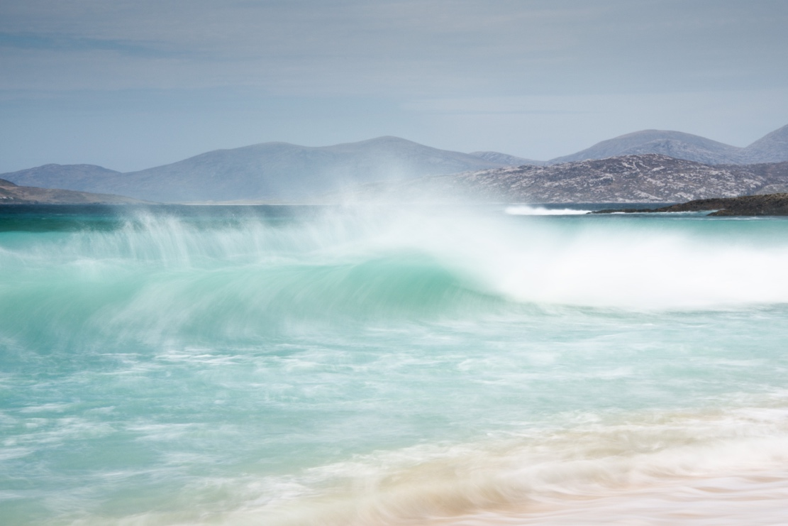
Scarista Wave Study 6 , Isle of Harris, Scotland 2019 | Margaret Soraya

“An exhibition celebrating the untouched beauty of the Scottish Hebrides, its remote rugged coastline and endless white sandy beaches. As an introvert who specifically visits these remote islands extending in an arc off the west coast of Scotland in search of solitude, Soraya’s work questions the cultural bias towards extroverts that exists in today’s western society, its obsession with personality over character, and reminds us of the healing power of solitude as the antidote to being constantly connected in today’s frantic digital world.”
Luke Whitaker, Director Bosham Gallery, September 2019

“Solitude is a positive state which can stimulate self-awareness and creativity. We all need periods of solitude to restore body and mind. As the world spins faster and faster and we become immersed in technology, we mortals need a variety of ways to cope with the resulting pressures. One of the best ways to maintain some semblance of balance is by seeking, and enjoying solitude; the state of being alone without feeling lonely, a constructive state of engagement with oneself and an opportunity to refresh and renew ourselves.”
Artist Margaret Soraya, September 2019

Exhibition Events:

Saturday 5th October | PRIVATE VIEW | 6.30-8.30pm
Sunday 3rd November | COLD WATER SWIMMING In Chichester Harbour With Margaret Soraya
Monday 4th November | LADIES DAY | Finding Solitude Through Photography
Wednesday 6th November | INTROVERT DAY | Are You An Introvert Or An Extrovert?

Media Contact:

Angus Haywood, Exhibitions Manager | angus@boshamgallery.com
1 High Street, Bosham, West Sussex, PO18 8LS England | +44(0)1243 681271
sales@boshamgallery.com | www.boshamgallery.com

END

