PRESS RELEASE- IMMEDIATE RELEASE

BOSHAM GALLERY HOSTS WORLD RENOWNED LANDSCAPE PHOTOGRAPHER’S LATEST WORK
1 April – 29 May 2017

Charlie Waite returns to Bosham Gallery, West Sussex with new work, showcasing his inimitable style, with spectacular images from around the world.
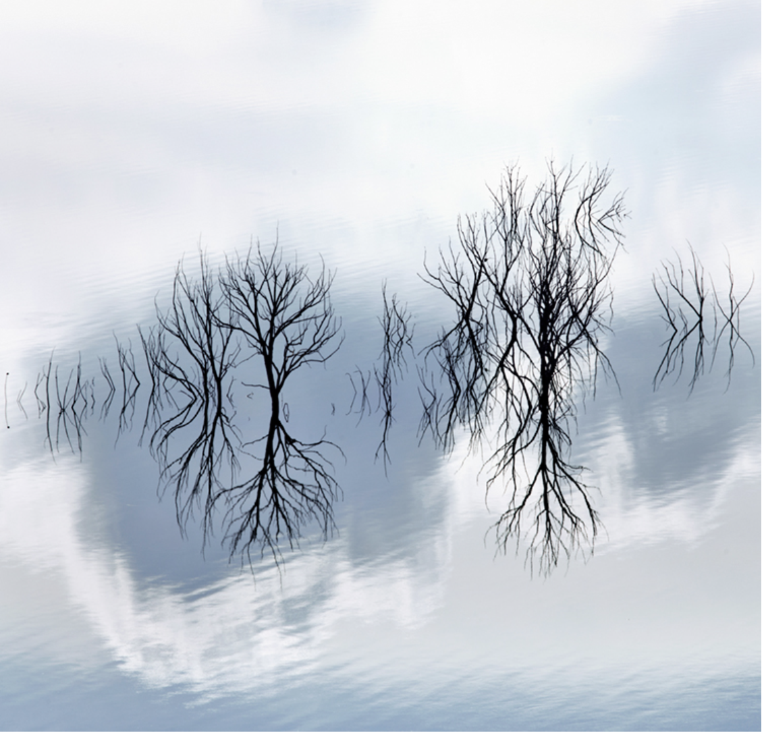Algar, Andalucia
“My photography offers me a pathway to wonder, to relish and to reaffirm and validate what I understand to be beautiful.” Charlie Waite

Charlie Waite offers us a window into his creative world, and shares the stories behind his collection of new and previously un-printed images at The Bosham Gallery in April and May.

“For an artist to have an exhibition of their work is always a humbling and privileged experience.
We set about what we do with the tools we use to express our feelings about our world around us; our responses, our interpretations and our questions and answers.
I am delighted to have been offered the intimacy of the Bosham gallery where I have been invited to show some recent work. The setting is beautiful.
There will be a number of occasions where I hope to be in the gallery and I shall very much look forward to having conversations with visitors about landscape photography and my recollections of the many joyous moments that I have had within it.
ENDS/ March 2017
For more information please contact
Luke Whitaker, Gallery Director
Bosham Gallery, No. 1 The High Street, Bosham, West Sussex, PO18 8LS
+44 (0) 1243 681271
luke@boshamgallery.com
http://www.boshamgallery.com/

NOTES TO EDITOR
Charlie Waite is now firmly established as one of the world’s leading Landscape photographers.

Having worked in Theatre and Television for the first ten years of his professional life, he became fascinated by theatrical lighting and design. Gradually the landscape and the way it can be revealed to us through light and shade stole him away from the acting profession.

His style is unique in that his photographs convey a spiritual quality of serenity and calm. He has established a worldwide reputation for his particular approach to his work and was invited to exhibit at Royal Academy of Arts. In 2014, he was awarded a Direct Fellowship by The Royal Photographic Society, has had numerous exhibitions worldwide and written over 30 books.
Waite has also done much to raise the profile of photography and in doing so has become the champion of the everyman photographer starting the annual Landscape Photographer of the Year Awards in the UK over 10 years ago and in 2013, he launched its sister competition in the U.S.A.

He is the owner and founder of Light and Land, Europe’s leading photographic tour company who run tours, courses and workshops worldwide supported by a select team of specialist photographic leaders.

www.charliewaite.com

